**Blinkit Sales Analysis Report (SQL-Based)**

The primary objective of this project is to comprehensively analyze Blinkit's business performance using Structured Query Language (SQL). The analysis focuses on extracting meaningful insights from a dataset that contains details about product sales, customer ratings, and outlet attributes.

**KPI Requirements**

1. **Total Sales**  
   The overall revenue is generated from all items sold.

select cast(sum(Sales)/1000000 as decimal(10,2)) as Total_Sales_in_Millions from blinkit_data;

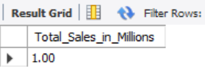

1. **Average Sales**  
   The average revenue per sale.

select cast(avg(Sales) as decimal(10,2)) as Average_Sales from blinkit_data;

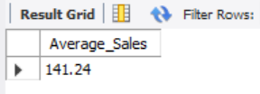

1. **Number of Items**  
   The total count of different items sold.

select count(*) as No_of_Items from blinkit_data;

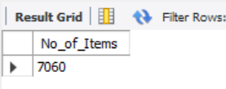

1. **Average Rating**  
   The average customer rating for items sold.

select cast(avg(Rating) as decimal(10,2)) as Average_Rzting from blinkit_data;

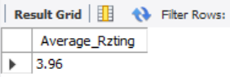

1. **Percentage of Sales by Outlet Size**

SELECT Outlet_Size,

CAST(SUM(Sales) AS DECIMAL(10,2)) AS Total_Sales,

CONCAT(CAST((SUM(Sales) * 100.0 / SUM(SUM(Sales)) OVER()) AS DECIMAL(10,2)), '%' ) AS Sales_Percentage FROM blinkit_data

GROUP BY Outlet_Size

ORDER BY Total_Sales DESC;

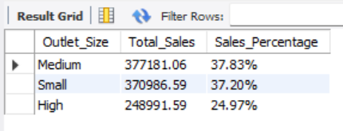

1. **Sales by Outlet Location**

select outlet_Location_Type, cast(sum(Sales) as decimal(10,2)) as Total_Sales,

cast(avg(Sales) as decimal(10,2)) as Average_Sales,CONCAT(CAST((SUM(Sales) * 100.0 / SUM(SUM(Sales)) OVER()) AS DECIMAL(10,2)), '%' ) AS Sales_Percentage,

count(*) as No_of_Items, cast(avg(Rating) as decimal(10,2)) as Average_Rating from blinkit_data

group by outlet_Location_Type;

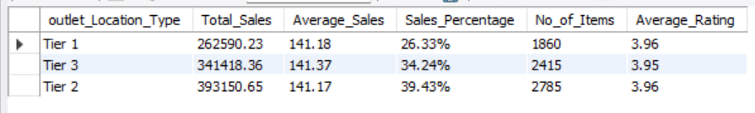

1. **All Metrics by Outlet Type**

select outlet_Type, cast(sum(Sales) as decimal(10,2)) as Total_Sales,

cast(avg(Sales) as decimal(10,2)) as Average_Sales,

CONCAT(CAST((SUM(Sales) * 100.0 / SUM(SUM(Sales)) OVER()) AS DECIMAL(10,2)), '%' ) AS Sales_Percentage,

count(*) as No_of_Items, cast(avg(Rating) as decimal(10,2)) as Average_Rating from blinkit_data

group by outlet_type

order by Total_Sales desc;

